MESSAGE PASSING APPLICATION

A MAJOR PROJECT
Submitted in partial fulfillment of the requirement for the award of the Degree of

BACHELOR OF ENGINEERING
IN
COMPUTER SCIENCE & ENGINEERING
SUBMITTED TO
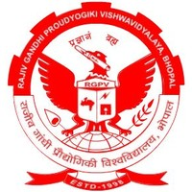

Rajiv Gandhi Proudyogiki Vishwavidyalaya, Bhopal(M.P.)
SUBMITTED BY
Parul Tiwari (0176CS161064)
Srashti Chalisgaonkar (0176CS161110)
Tegjot Singh Sehgal(0176CS161115)
Lakshmi Narain College of Technology Excellence, Bhopal (M.P.), India

UNDER THE SUPERVISION OF

HARENDRA SINGH
Asst.Professor, Department of Computer Science & Engineering
Lakshmi Narain College of Technology Excellence, Bhopal (M.P.), India



Department of Computer Science & Engineering
Lakshmi Narain College of Technology Excellence, Bhopal(M.P.) Session: DEC-MAY 2020

(Approved by AICTE, New Delhi & Affiliated to RGPV, Bhopal)
Kalchuri Nagar, Raisen Road, Bhopal (M.P.)
Email: lnctebhopal@lnctgroup.in, Website: www.lnctgroup.in
Phone: +91-7553985300, 7553985301, 7553985302, 7553985303

CANDIDATE’S DECLARATION
I, Parul Tiwari and Srashti Chalisgaonkar, student of Bachelor of Engineering, Computer Science & Engineering, Lakshmi Narain College of Technology Excellence, Bhopal hereby declare that the work presented in the dissertation entitled “ Message Passing Application ” is outcome of my own bona-fide work, which is correct to the best of my knowledge and this work has been carried out taking care of Engineering Ethics. The work presented does not infringe any previous work and has not been submitted to any University for the award of any degree / diploma.

The dissertation entitled “Message Passing Application” being submitted by “Parul Tiwari ” (0176CS16064) ,“ Srahti Chalisgaokar ” (0176CS16110) and “Tegjot Singh Sehgal” (0176CS161115) has been examined by us and is hereby approved for the award of degree “Bachelor of Engineering in Computer Science & Engineering”, for which it has been submitted. It is understood that by this approval the undersigned do not necessarily endorse or approve any statement made, opinion expressed or conclusion drawn therein, but approve the dissertation only for the purpose for which it has been submitted.

(Approved by AICTE, New Delhi & Affiliated to RGPV, Bhopal)
Kalchuri Nagar, Raisen Road, Bhopal (M.P.)
Email: lnctebhopal@lnctgroup.in, Website: www.lnctgroup.in
Phone: +91-7553985300, 7553985301, 7553985302, 7553985303

ACKNOWLEDGEMENT

At the outset, we would like to link to thank the Almighty who made all the things possible. Writing this project report would not have been possible without the support of several people whom we need to wholeheartedly thank. A special thank of ours goes to “Dr. Megha Kamble” Prof.& Head, Department of Computer Science and Engineering ,LNCTE ,Bhopal who helped us in completing the research and exchanged his interesting ideas thoughts and made this research easy accurate .
We are equally grateful to Dr.V.K. Sahu, principal, LNCTE for providing all the necessary resources to carry out this project work. We would like to thank all staff members of CSE, L.N.C.T.E. and friends, for their moral and psychological support.
We will be failing in our duty if we don’t acknowledge the authors whose work has been consulted by us during the project work

Parul Tiwari (0176CS16064)
Srashti Chalisgaonkar (0176cs161110)
Tegjot Singh Sehgal (0176CS161110)

ABSTRACT

CONTENT

Introduction | 6
Purpose | 7
Proposed approach | 8
Languages and tools methodology | 9
Architecture | 10
Model | 11-12
RAD Model | 13
Data flow Diagram and Overview | 14-15
Requirements | 16
Technology | 17
Testing | 18
Future enhancement | 19
Application | 20
Conclusion | 21

INTRODUCTION
Message Passing Application is a standalone application that is made up the combination of two-application, server application and client application .This application is used for chatting in LAN. To start chatting you must be connected with the server after that your message can broadcast to client.
For making this application we are using some core java features like swing, collection, networking, I/O Streams and threading also. In this application we have one server and many clients. For making a server we have to run the ChatServerGUI.java file at any system on the network that we want to make server and for client we have to run ChatClientGUI.java file on the system that we want to make client.

PURPOSE
This Project Entitled as “Message Passing Application‟ is used basically for chatting purpose with the remote clients or users on Internet or local networks. Here in this project a java client / server combination is used to chat with remote users.
When a Client wants to chat with a user on a remote host, he sends a request to the Server with a identification like host if local or remote, the server responds to the request by identifying the host and when his request is granted and the client can begin to chat with the remote users present on the internet or local network.

PROPOSED APPROACH
Create the chat server for the chat application. The server must be written in core JAVA and must use sockets. It must run on the instructional machines.

The chat server is responsible for providing a mechanism for the clients to communicate.

This includes allowing clients to give port number and user name then writing message from one client destined to server. This also includes listing the usernames of the clients.

LANGUAGES AND TOOLS
METHODOLOGY
This approach poses a challenge for data synchronization between heterogeneous data stores. One resolution to this problem is a Java-based approach using JDBC. Distributed databases use a client/server architecture to process information requests.
Server Side:
Server controls, manages the entire system and stores the complete details regarding their client. And when request arises, authentication is done and the server provides the details for the corresponding ones. The server will do the entire work as a background process. The user does not have any interaction with servers. In this system the data request once arrived, is accepted from client and. according to the client's request and sent the data.

Client Side:
This Client-side software will always interact with users working as the front-end. First of all a connection is established with server. Then make appropriate request for data. Display the data in the user requested format. Getting specification from the user is the main functionalities of the client side and passes it to server side for processing.

Architecture

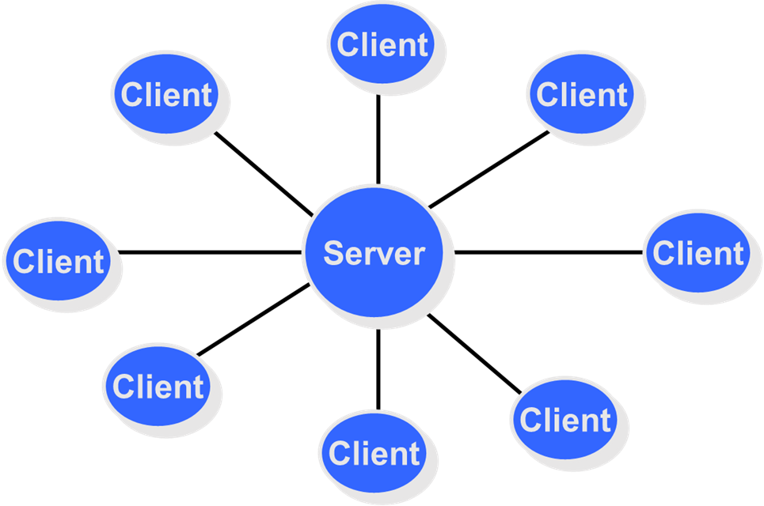

Model :

Rapid application development is a software development methodology that involves methods like iterative development and software prototyping. According to Whitten (2004), it is a merger of various structured techniques, especially data-driven Information Engineering, with prototyping techniques to accelerate software systems development.

In rapid application development, structured techniques and prototyping are especially used to define users' requirements and to design the final system. The development process starts with the development of preliminary data models and business process models using structured techniques. In the next stage, requirements are verified using prototyping, eventually to refine the data and process models.

These stages are repeated iteratively; further development results in "a combined business requirements and technical design statement to be used for constructing new systems".

RAD is incremental software development process model that allows usable systems to be built in as little as 60-90 days, often with some compromises. The RAD model used for information systems development. The RAD model contains the following phases:

• Business modelling
• Data modelling
• Proccess modeling
• Application generation
• Testing and turnover

Advantages of using RAD:-

There are many advantage of using RAD and it can solve many concerns of the user as well as developers.

- Quicker visualization of end design – conventional software development method take on an average 20% more time than RAD procedure. Hence using RAD allow rapid software testing and rectifying steps.

- Faster to update according to customer requirement – current competitive scenario demands frequently upgraded softwares in order to effectively satisfy customers requirements. It enables it by systematically eliminating the redundant steps or using the prototyping methods.

- Meeting time constraints-isolating the units, testing each, then integrating them and testing the whole.

RAD model :-

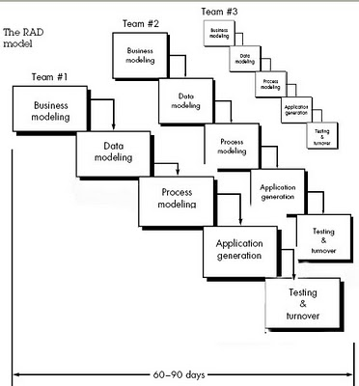

DATA FLOW DIAGRAM:-
Context level :

Response
server
connection
client

store info
request for connection

OVERVIEW

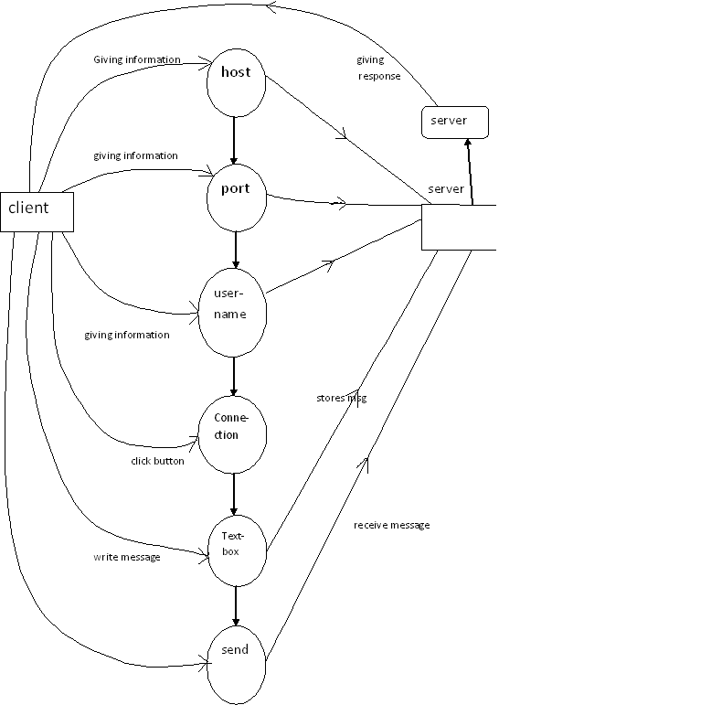

Requirements
Hardware Requirement :-
Chat Server Software will be compatible with most server hardware.
The minimum hardware
- 100 MB free hard disk space or more

Other hardware requirements are as follows:
- 1 GHz or faster processor Windows
- 256 MB of RAM or more

Software Requirements:-
- Operating system 98/NT/2000/XP/Vista/7
- Front end- core java.

TECHNOLOGY
This project will be using technology java and as a front-end.

JAVA
Java is a programming language created by James Gosling from Sun Microsystems in 1991. The first public available version of Java (Java 1.0) was released 1995. Over time several version of Java were released which enhanced the language and its libraries.

The current version of Java is Java 1.6 also known as Java 6.0. From the Java programming language the Java platform evolved. The Java platform allows that code is written in other languages then the Java programming language and still runs on the Java virtual machine.

The Java programming language consists out of a Java compiler, the Java virtual machine, and the Java class libraries. The Java virtual machine (JVM) is a software implementation of a computer that executes programs like a real machine.

The Java compiler translates Java coding into so-called byte-code. The Java virtual machine interprets this byte-code and runs the program. The Java virtual machine is written specifically for a specific operating system.

TESTING
After coding, software will be tested whether desired and correct output has been generated or not. The concerned department will checthe report on the operation data. Testing will be carried out for logic checking. Method we will use in testing in unit testing.

Unit testing:
The primary goal of unit testing is to take the smallest piece of testable software in the application, isolate it from the remainder of the code, and determine whether it behaves exactly as you expect.

Each unit is tested separately before integrating them into modules to test the interfaces between modules. Unit testing has proven its value in that a large percentage of defects are identified during its use.

For example, if you have two unit and decided would be more cost effective to glue them together and initially test them as an integrated unit, an error could occur in a variety of places.

Is the error due to a defect in unit 1?
Is the error due to a defect in unit 2?
Is the error due to a defect in both unit?
Is the error due to a defect in the interface between the units?
Is the error due to a defect in test?

FUTURE ENHANCEMENT

“CHANGES ARE LAWS OF NATURE”
“No project is perfect; there is always some scope of future modification in nature.”

The statements holds true for this project also. Whatever it is large or small always having some limitation no matter how so ever diligently developed. The main reasons of limitations are complexity of project, mode of operation, cost, span of time etc.

This project can be improved further.

APPLICATION

- The server provides services and data
- The server abstracts communication and information access, allowing clients to make simplified requests for services and data.
- The client handles all aspects of data presentation and the user's interface.
- The application is modelled as a set of services that
are provided by servers and a set of clients that use
these services.
- Clients know of servers but servers need not know of
clients.
- Clients and servers are logical processes.

CONCLUSION
We can conclude that this project enables easy decision making with the support of correct and precise information, Accurate and timely reports as there would be less chance for errors in transactions. The new system can lead to increase in transactions i.e., more billing, more booking as the computerization speeds up operations, Increase in revenue due to increase in transactions and prevents loss of revenue. Management authorities can collect reports at any point of time from software. They need not worry about the delay in reports from finance and other departments. Computers can handle large volume of data without any frustrations.
As the software is totally integrated, there is no question of increased data entry problems. As the software comes with very flexible user interface, users will feel very comfortable with new environment.

SCREENSHOTS
